

[Project]

DETAIL DESIGN DOCUMENT

Screen design

**Project Code: ChatLoca**

**Document Code: ChatLoca – DD – v1**

**Bach Khoa University, 10/03/2018**

Record of change

*A - Added M - Modified D – Deleted

|  |  |  |  |  |
| --- | --- | --- | --- | --- |
| Effective Date | Changed Items | A* M, D | Change Description | New Version |
|  |  |  |  |  |
|  |  |  |  |  |
|  |  |  |  |  |
|  |  |  |  |  |
|  |  |  |  |  |
|  |  |  |  |  |
|  |  |  |  |  |
|  |  |  |  |  |
|  |  |  |  |  |
|  |  |  |  |  |
|  |  |  |  |  |
|  |  |  |  |  |
|  |  |  |  |  |

SIGNATURE PAGE

**ORIGINATOR:** Nguyễn Đỗ Đức Anh 08/03/2018

Leader

**REVIEWERS:** Hoàng Hùng 10/03/2018

TA

Nguyễn Thành Đạt 09/03/2018

Member

Nguyễn Thành Công 09/03/2018

Member

Nguyễn Trọng Tín 09/03/2018

Member

**APPROVAL:** Nguyễn Đỗ Đức Anh 09/03/2018

Leader

1 Introduction 5

1.1 Purpose 5

1.2 Definitions, Acronyms and Abbreviations 5

1.3 References 5

1.4 Overview 6

2 screen Flow 7

2.1 Login 9

2.2 Sign up 10

2.3 Profile 12

2.4 Location 15

2.5 Message 17

2.6 Chat 21

3 Other considerations 24

# Introduction

## Purpose

**This Design Document** provides the screen design details of Chat Loca Application in the scope of Software engineering Subject and aims to provide a guide to a design that could be easily implemented by any designer reading this document. Throughout the document, Screen structure, interface design and implementation strategies will be explained in detail.

## Definitions, Acronyms and Abbreviations

|  |  |  |
| --- | --- | --- |
| Abbreviations | Description | Comment |
| DD | Design Document |  |
| UI | User Interface |  |

## References

|  |  |
| --- | --- |
| Document Number | Title |
| [1] | D-BUG Detailed Design Document |

## Overview

**This DD** is divided into three sections in order to provide a complete and understandable perception about the UI of the system to the target readers. First section is mostly about the scope and purpose of the document. This section also includes the definition of the problem that is intended to be solved.

**In the second part**, screen flow, is all about the UI design. In this section, a general description of UI include the screen structure and screens are provided, the functionality and expected features of the user interface is given. In addition, some possible screenshots showing the interface from the user’s perspective are provided and purpose of the screen objects is explained.

**The last part** provide a brief explanation of advantages and disadvantages of the selected screen flows .

# screen Flow

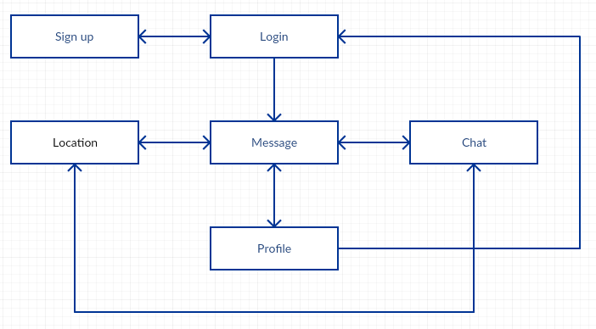

**Figure 1: Screen Structure**

|  |  |  |
| --- | --- | --- |
| No | Screen Name | Description |
| 1 | Login | The first screen of the app to sign in the system |
| 2 | Sign up | Screen for sign up a new account |
| 3 | Profile | Screen inlude Account's information, Picture, Friend Request |
| 4 | Location | Screen perform the location of Users |
| 5 | Message | Screen include user's message of friend or group |
| 6 | Chat | In this screen, user can enter message and send to others |

## Login

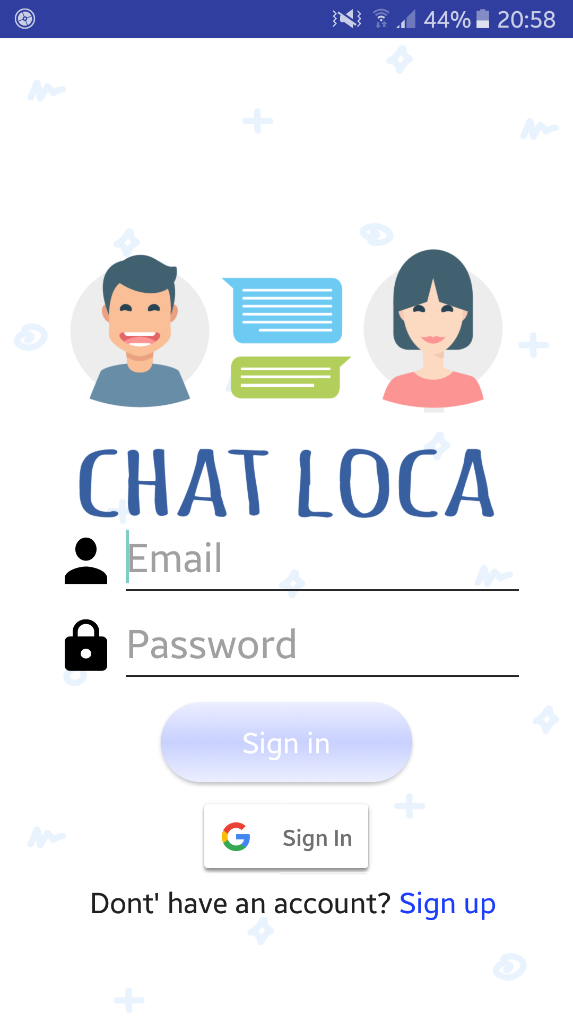

**Figure 2.1: Login**

**Sreen 2.1**

|  |  |  |  |  |  |
| --- | --- | --- | --- | --- | --- |
| No | Component Name | Required | Format | Reference | Note |
| 1 | Username | String | Text Input | Keyboard | Account's ID |
| 2 | Password | String | Text Input | Keyboard | Account's Password |
| 3 | Sign in | None | Button | Touch | Log into account, show screen 'Message' |
| 4 | Sign in with Gmail | None | Button | Touch | Log in by gmail, show screen 'Message' |
| 5 | Sign up | None | TextView | Touch | Start sign up new account, show screen 'Sign up' |

## Sign up

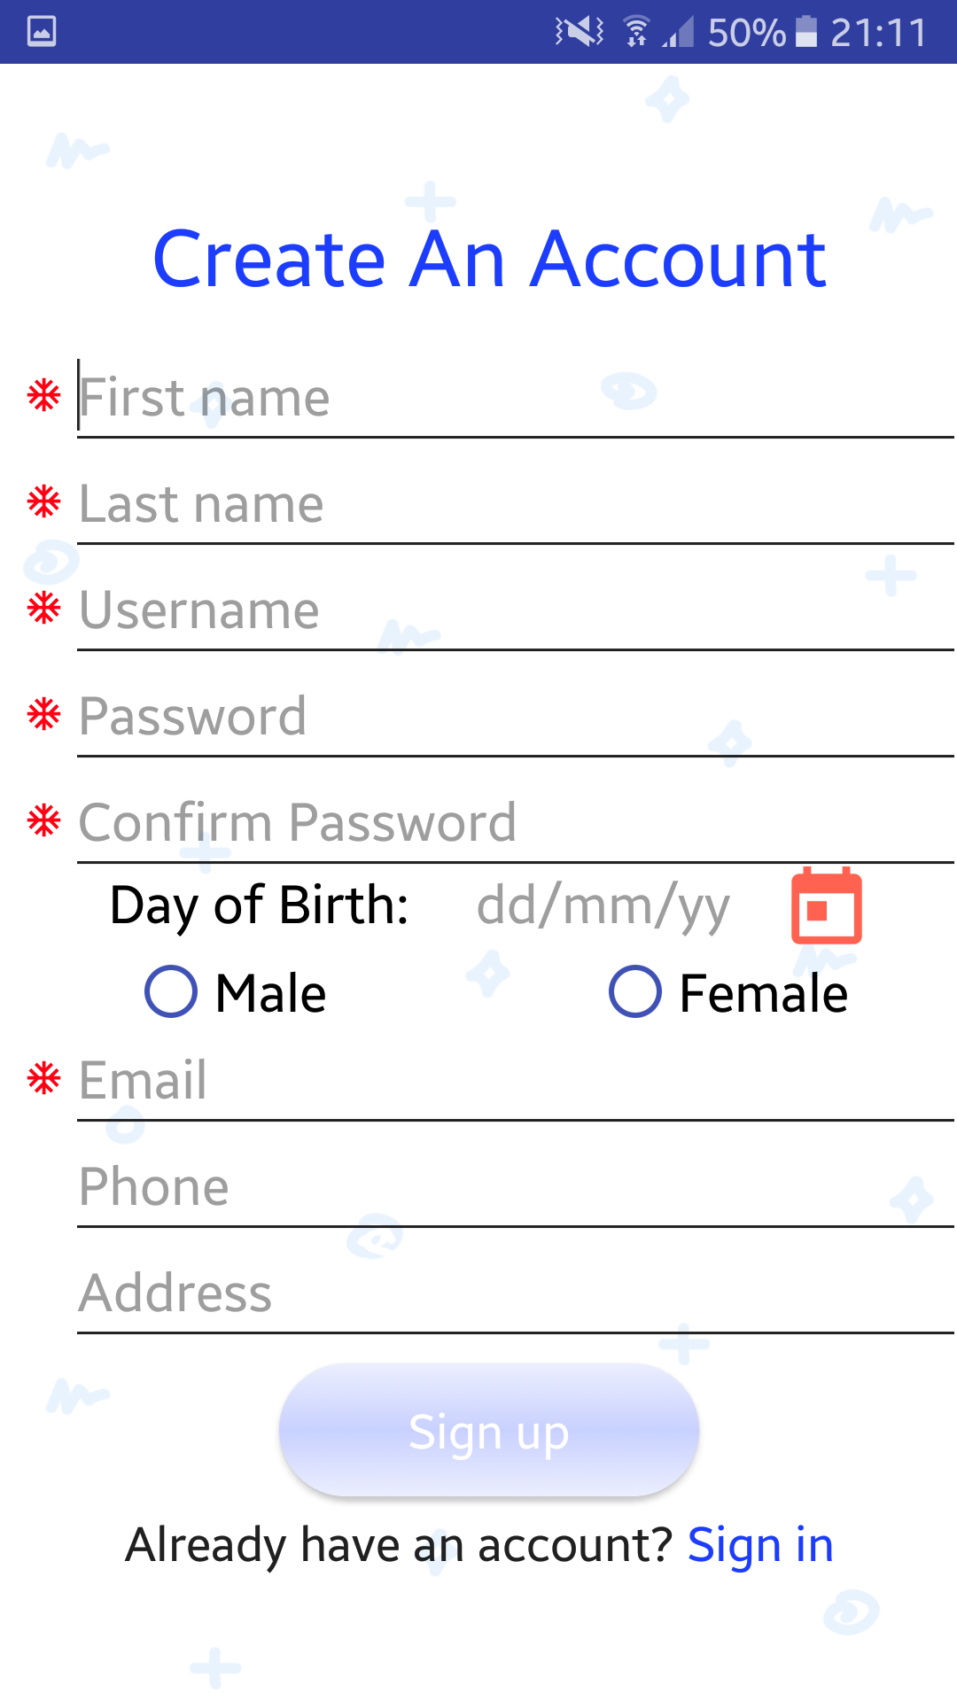

**Figure 2.2: Sign up**

**Sreen 2.2**

|  |  |  |  |  |  |
| --- | --- | --- | --- | --- | --- |
| No | Component Name | Required | Format | Reference | Note |
| 1 | First name | String | Text Input | Keyboard | User's first name |
| 2 | Last name | String | Text Input | Keyboard | User's last name |
| 3 | Username | String | Text Input | Keyboard | Account's ID |
| 4 | Password | String | Text Input | Keyboard | Account's Password |
| 5 | Confirm Password | String | Text Input | Keyboard | Rewrite account's Password |
| 6 | Day of Birth | None | TextView | Touch | Select user's Birthdate |
| 7 | Male | None | Radio | Touch | Choose if user's gender is male |
| 8 | Female | None | Radio | Touch | Choose if user's gender is female |
| 9 | Email | String | Text Input | Keyboard | User's email |
| 10 | Phone | Number | Text Input | Keyboard | User's phone number |
| 11 | Address | String | Text Input | Keyboard | User's address |
| 12 | Sign up | None | Button | Touch | Start sign up new account |
| 13 | Sign in | None | TextView | Touch | Show screen 'Login |

## Profile

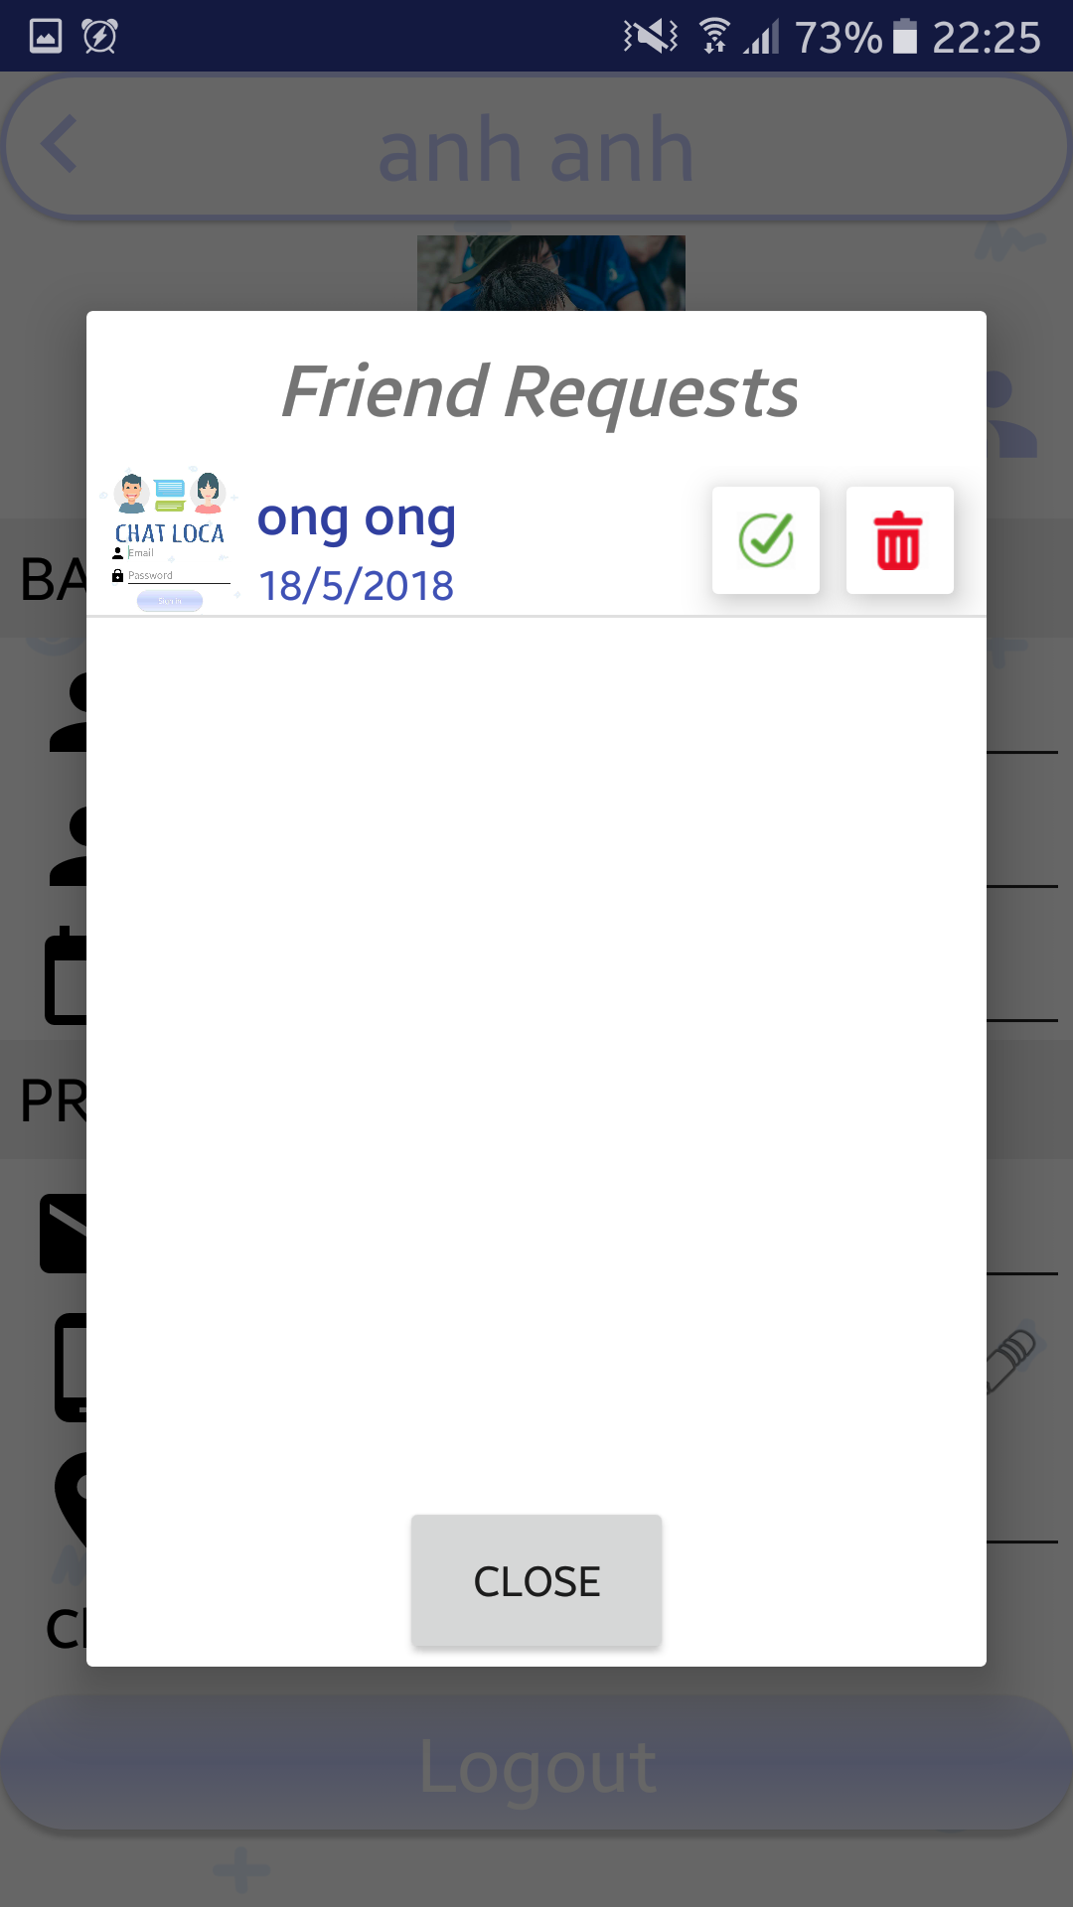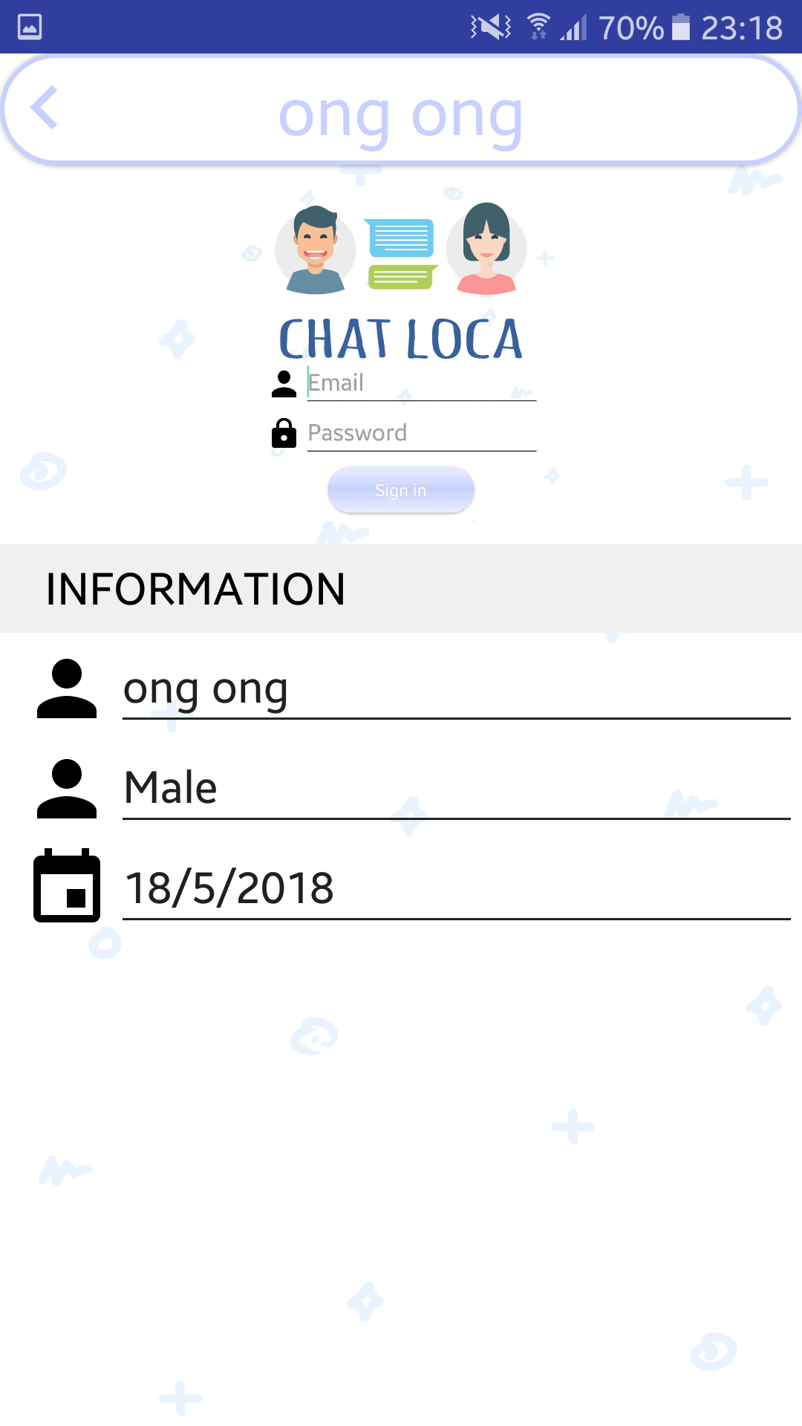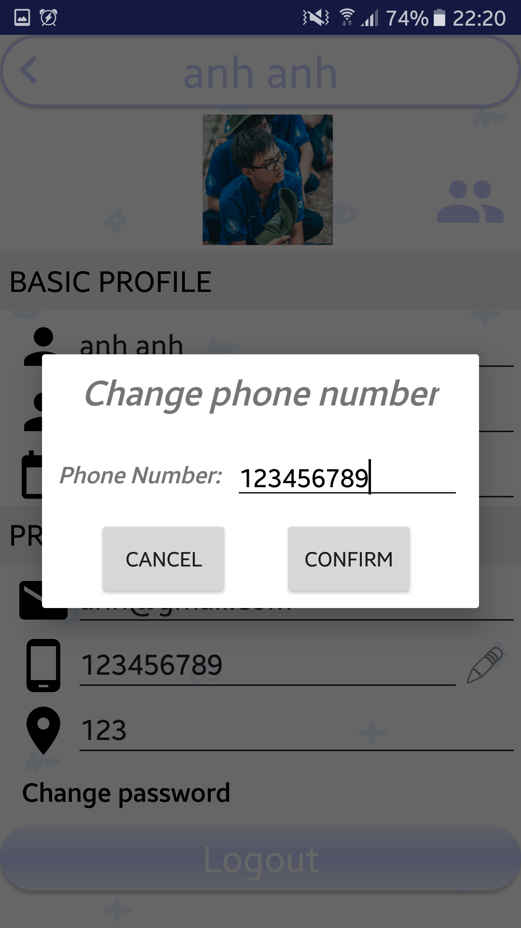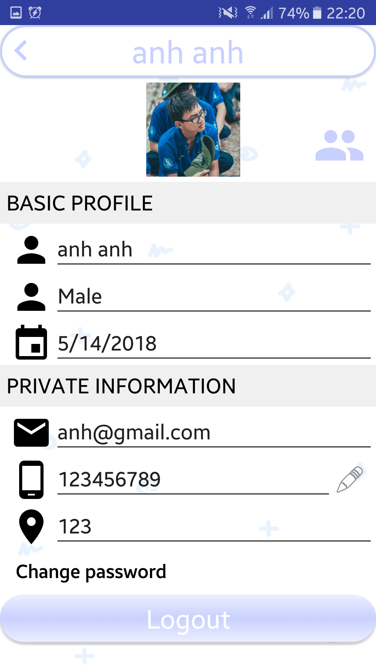

**Figure 2.3.1: Profile Figure 2.3.2: Edit Phone Number Figure 2.3.3: Friend's Request Figure 2.3.4: Other's Profile**

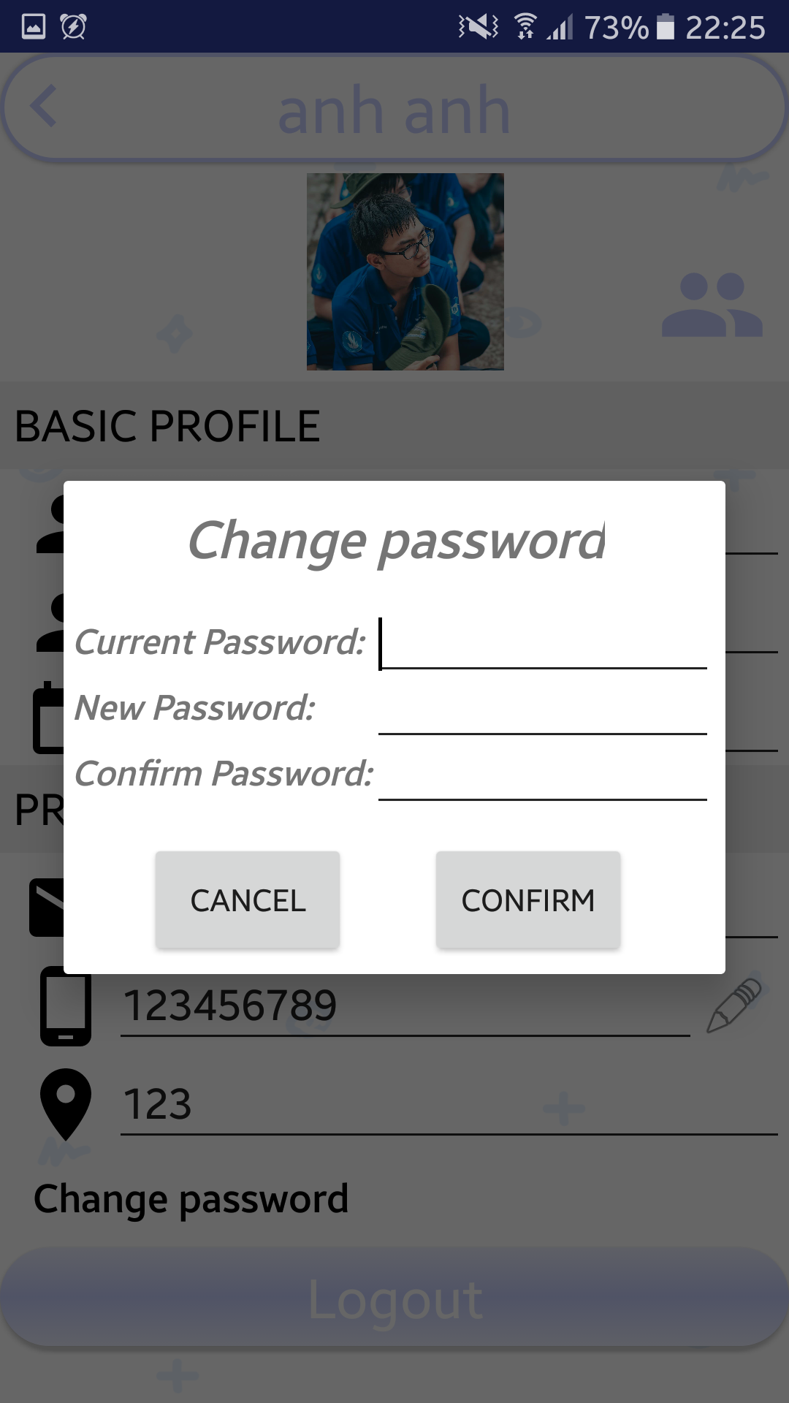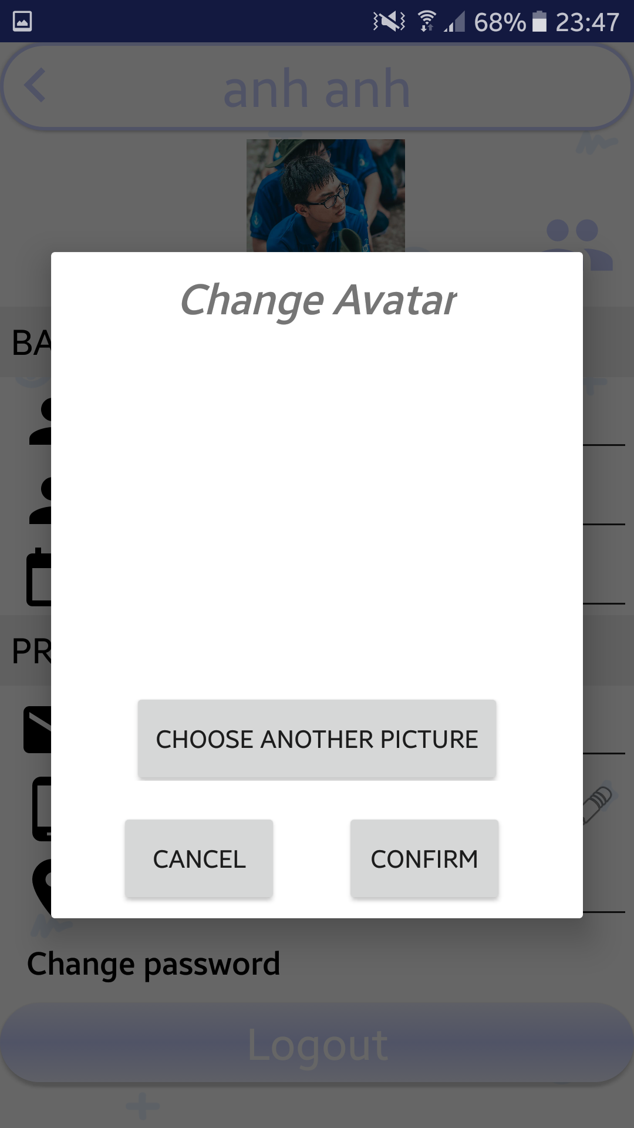

**Figure 2.3.5: Change Avatar Figure 2.3.6: Change Password**

**Sreen 2.3.1**

|  |  |  |  |  |  |
| --- | --- | --- | --- | --- | --- |
| No | Component Name | Required | Format | Reference | Note |
| 1 | Back | None | Button | Touch | Go back to screen 'Message' |
| 2 | Friend's Request | None | Icon | Touch | Show up friend's request |
| 3 | Edit phone number | None | Icon | Touch | Show up editing phone number view |
| 4 | Change password | None | TextView | Touch | Show up editing password view |
| 5 | Logout | None | Button | Touch | Log out account, show up screen 'Sign in' |

**Sreen 2.3.2**

|  |  |  |  |  |  |
| --- | --- | --- | --- | --- | --- |
| No | Component Name | Required | Format | Reference | Note |
| 1 | Change number | Number | EditView | Keyboard | Change phone number |
| 2 | Cancel Edit | None | Button | Touch | Close edit phone number without changing |
| 3 | Confirm Edit | None | Button | Touch | Close edit phone number, save changes |

**Sreen 2.3.3**

|  |  |  |  |  |  |
| --- | --- | --- | --- | --- | --- |
| No | Component Name | Required | Format | Reference | Note |
| 1 | Friend's Avatar | None | Image | Touch | Show up friend's account's Profile screen |
| 2 | User's name | None | Label | Touch | Show up user's basic information |
| 4 | Deny | None | Button | Touch | Remove friend's request |
| 5 | Accept | None | Button | Touch | Accept friend's request |

**Sreen 2.3.4**

|  |  |  |  |  |  |
| --- | --- | --- | --- | --- | --- |
| No | Component Name | Required | Format | Reference | Note |
| 1 | Back | None | Button | Touch | Back to the Screen before |

**Sreen 2.3.5**

|  |  |  |  |  |  |
| --- | --- | --- | --- | --- | --- |
| No | Component Name | Required | Format | Reference | Note |
| 1 | Cancel | None | Button | Touch | Cancel change avatar |
| 2 | Confirm | None | Button | Touch | Confirm new avatar |
| 3 | Choose picture | None | Button | Touch | Select the picture in device to change |

**Sreen 2.3.6**

|  |  |  |  |  |  |
| --- | --- | --- | --- | --- | --- |
| No | Component Name | Required | Format | Reference | Note |
| 1 | Cancel | None | Button | Touch | Cancel change password |
| 2 | Confirm | None | Button | Touch | Confirm new password |
| 3 | Current Password | String | EditText | Keyboard | Enter current password |
| 4 | New Password | String | EditText | Keyboard | Enter new password |
| 5 | Confirm Password | String | EditText | Keyboard | Enter new password again |

## Location

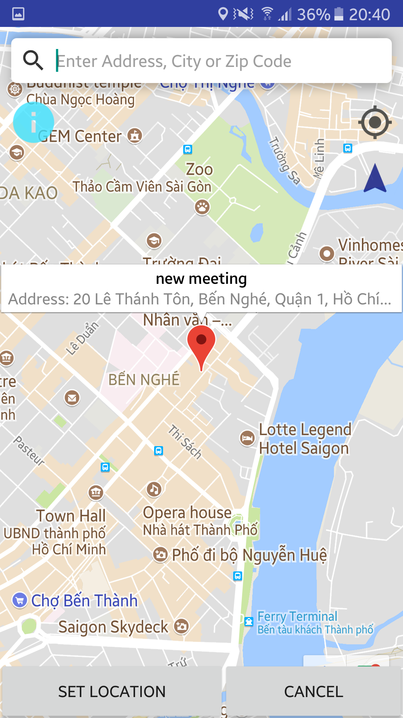

**Figure 2.4: Location**

**Sreen 2.4**

|  |  |  |  |  |  |
| --- | --- | --- | --- | --- | --- |
| No | Component Name | Required | Format | Reference | Note |
| 1 | Back | None | Icon | Touch | Go back to screen 'Message' or 'Chat' |
| 2 | Name | String | TextView | None | Show meeting's name |
| 3 | Location | String | TextView | None | Show meeting's location |
| 4 | Name of Location | String | TextView | None | Show meeting's location's name |
| 5 | Map | None | Map | None | Show map |
| 6 | Position | None | Icon | None | Meeting Position on map |

## Message

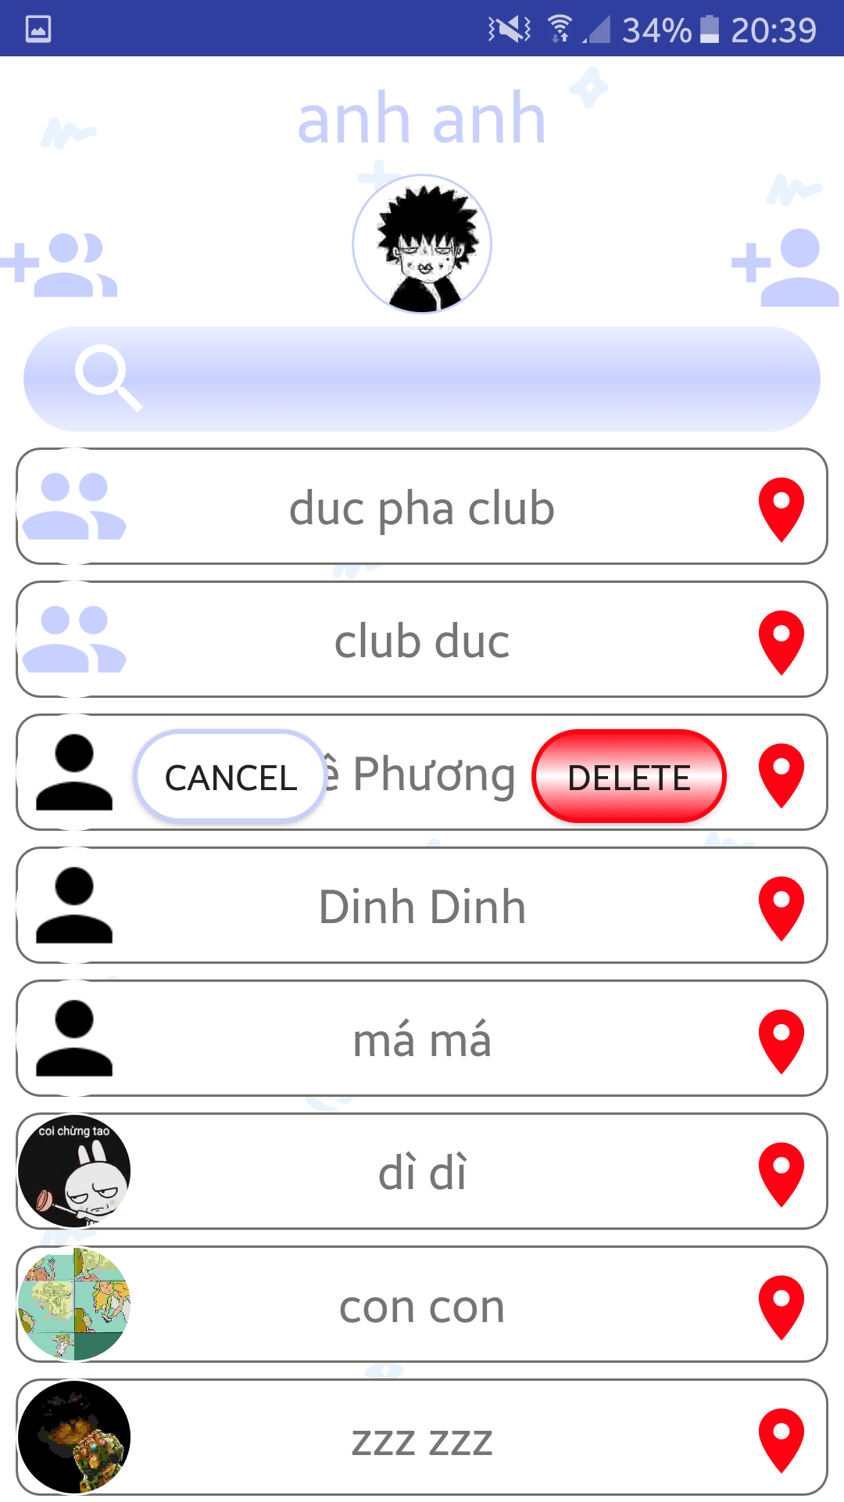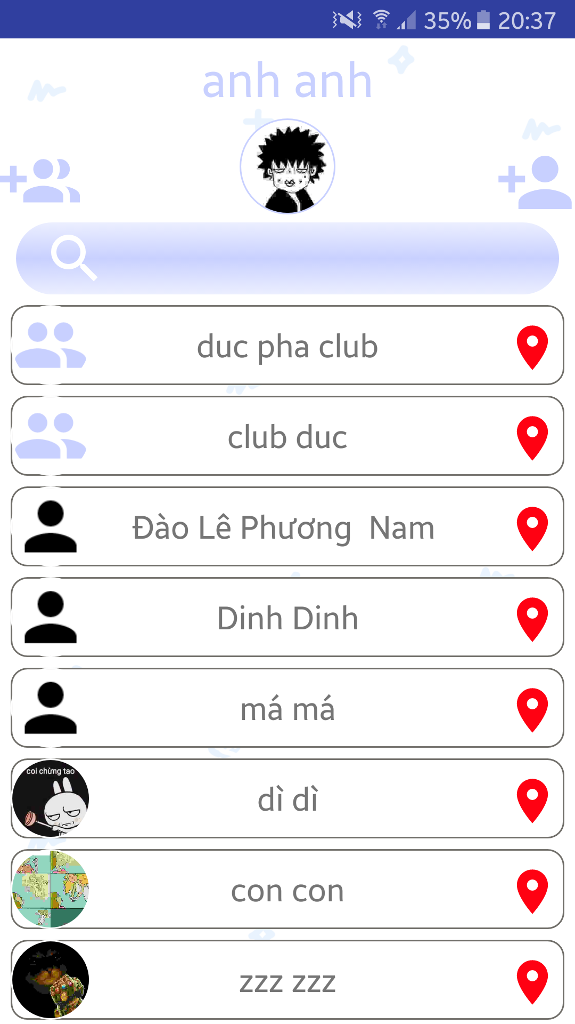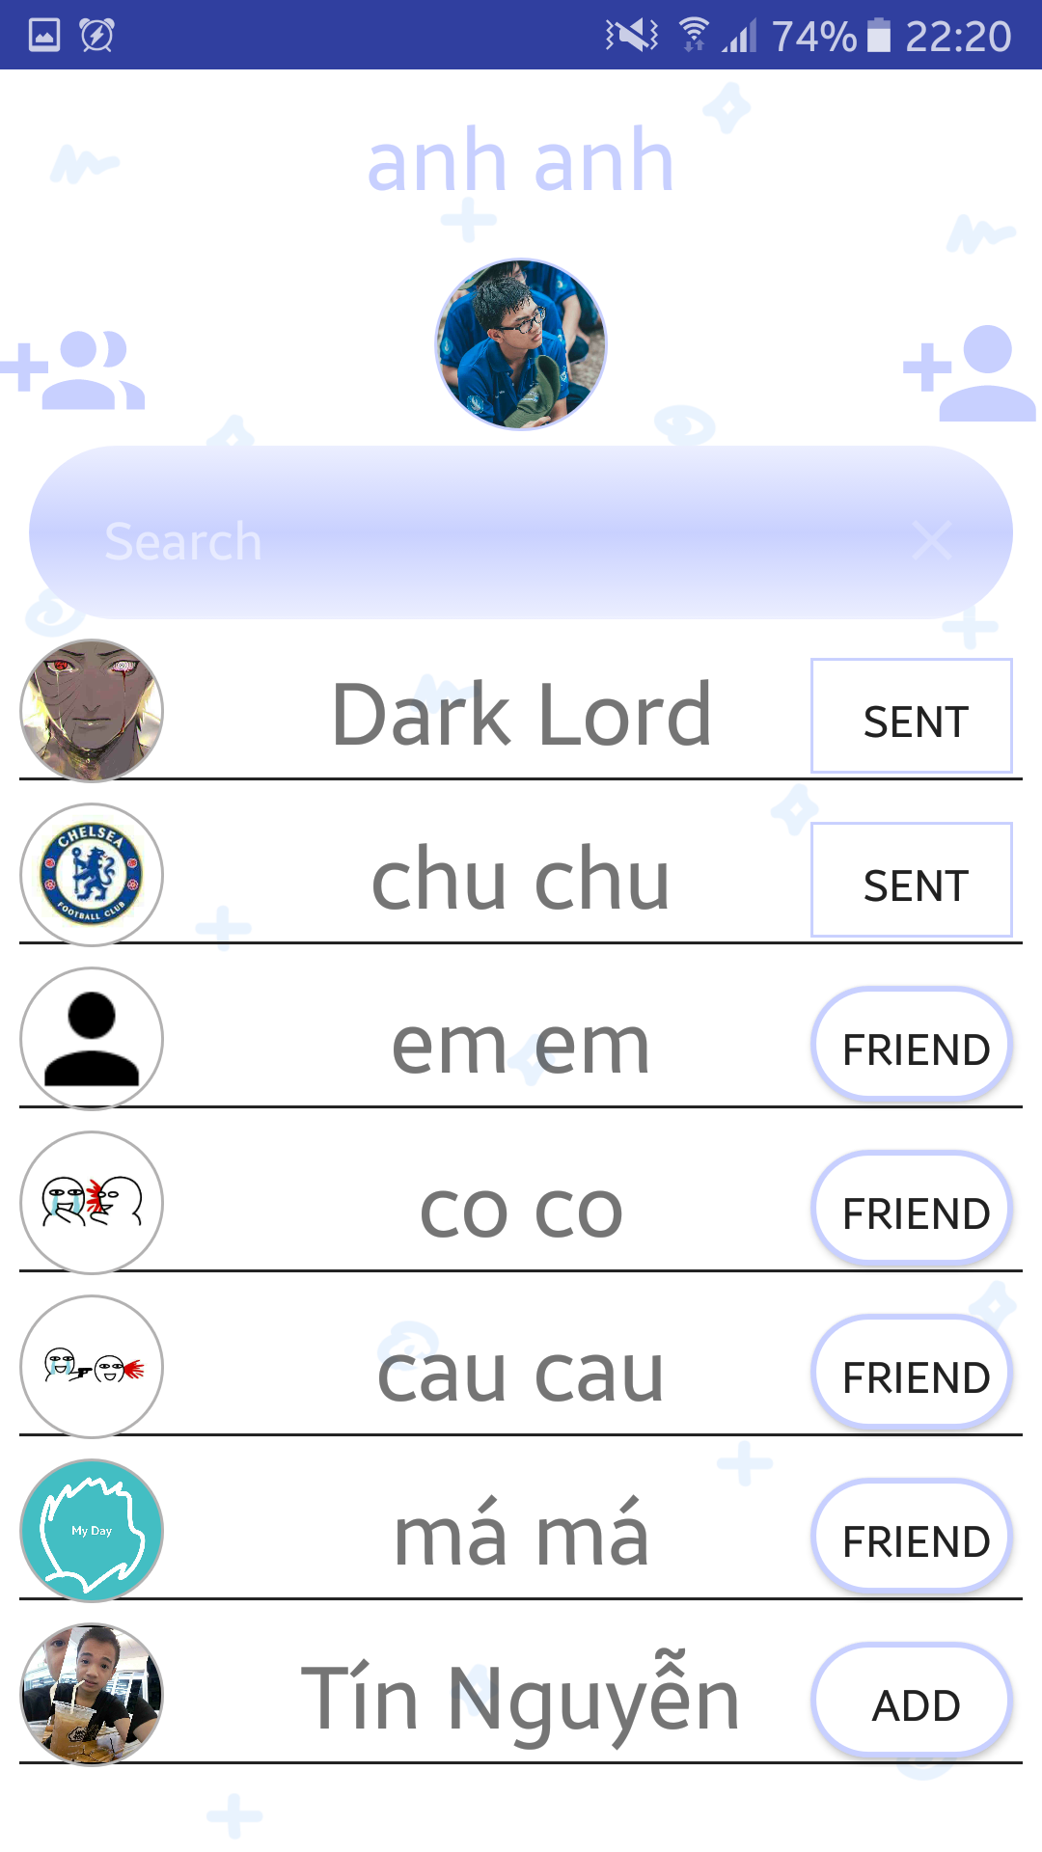

**Figure 2.5.1: Message Figure 2.5.2: Delete Friend Figure 2.5.3: Search Friend Add**

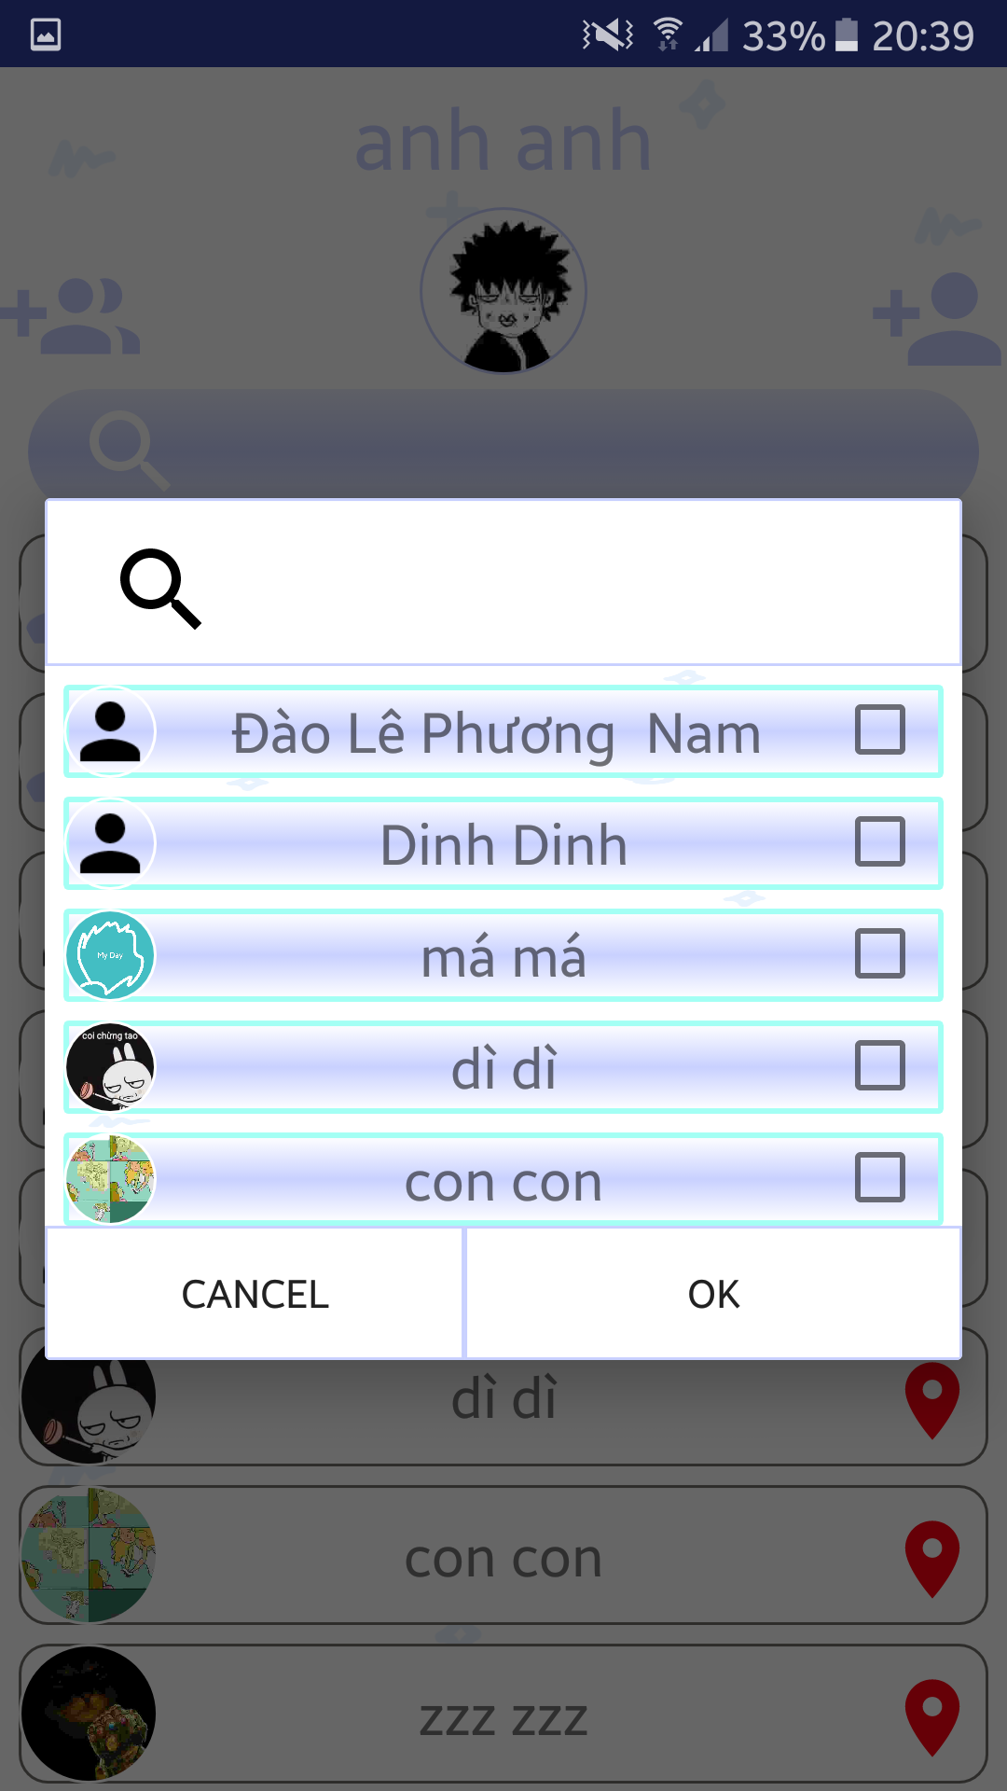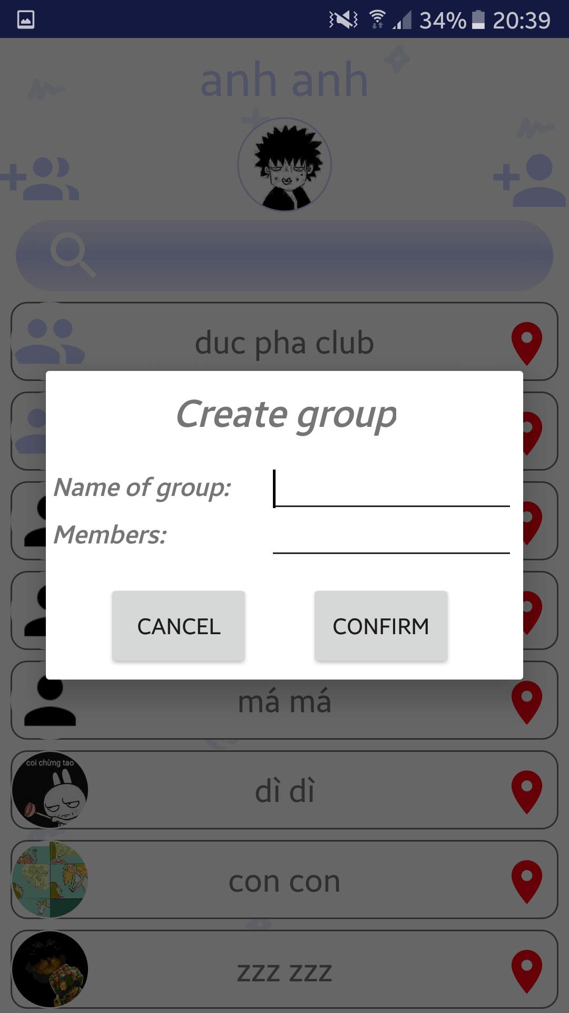

**Figure 2.5.4: Create Group Figure 2.5.5: Select Member**

**Screen 2.5.1, 2.5.2**

|  |  |  |  |  |  |
| --- | --- | --- | --- | --- | --- |
| No | Component Name | Required | Format | Reference | Note |
| 1 | Add group | None | Icon | Touch | To create new group chat of friends |
| 2 | Avatar | None | Image | Touch | Show up screen 'Profile' of account |
| 3 | Add friend | None | Icon | Touch | To add new friend chat |
| 4 | Search | String | SearchView | Keyboard | Find friend chat in account's list of friends |
| 5 | Message | None | Label | Touch | Show screen 'Chat' of user's friend or group |
| 6 | Locate | None | Icon | Touch | Show screen 'Location' of meeting |
| 7 | Cancel | None | Button | Touch | Cancel delete friend |
| 8 | Delete | None | Button | Touch | Delete friend |

**Screen 2.5.3**

|  |  |  |  |  |  |
| --- | --- | --- | --- | --- | --- |
| No | Component Name | Required | Format | Reference | Note |
| 1 | Search | String | SearchView | Keyboard | Remove friend from list of friends |
| 2 | Add Friend | None | Button | Touch | Send request friend |
| 3 | Show Info | None | TextView | Touch | Show screen User's Profile |

**Sreen 2.5.4**

|  |  |  |  |  |  |
| --- | --- | --- | --- | --- | --- |
| No | Component Name | Required | Format | Reference | Note |
| 1 | Name Of Group | String | Text Input | Keyboard | Enter name of group |
| 2 | Members | String | TextView | Touch | Show View friend's list |
| 3 | Cancel | None | Button | Touch | Stop creating group |
| 4 | Confirm | None | Button | Touch | Create group |

**Sreen 2.5.5**

|  |  |  |  |  |  |
| --- | --- | --- | --- | --- | --- |
| No | Component Name | Required | Format | Reference | Note |
| 1 | Search | String | SearchView | Keyboard | find friend in the list |
| 2 | Choose member | None | CheckBox | Touch | Choose or remove member of group |
| 3 | Cancel | None | Button | Touch | Stop view without choosing member |
| 4 | OK | None | Button | Touch | Accept choosen friends |

## Chat

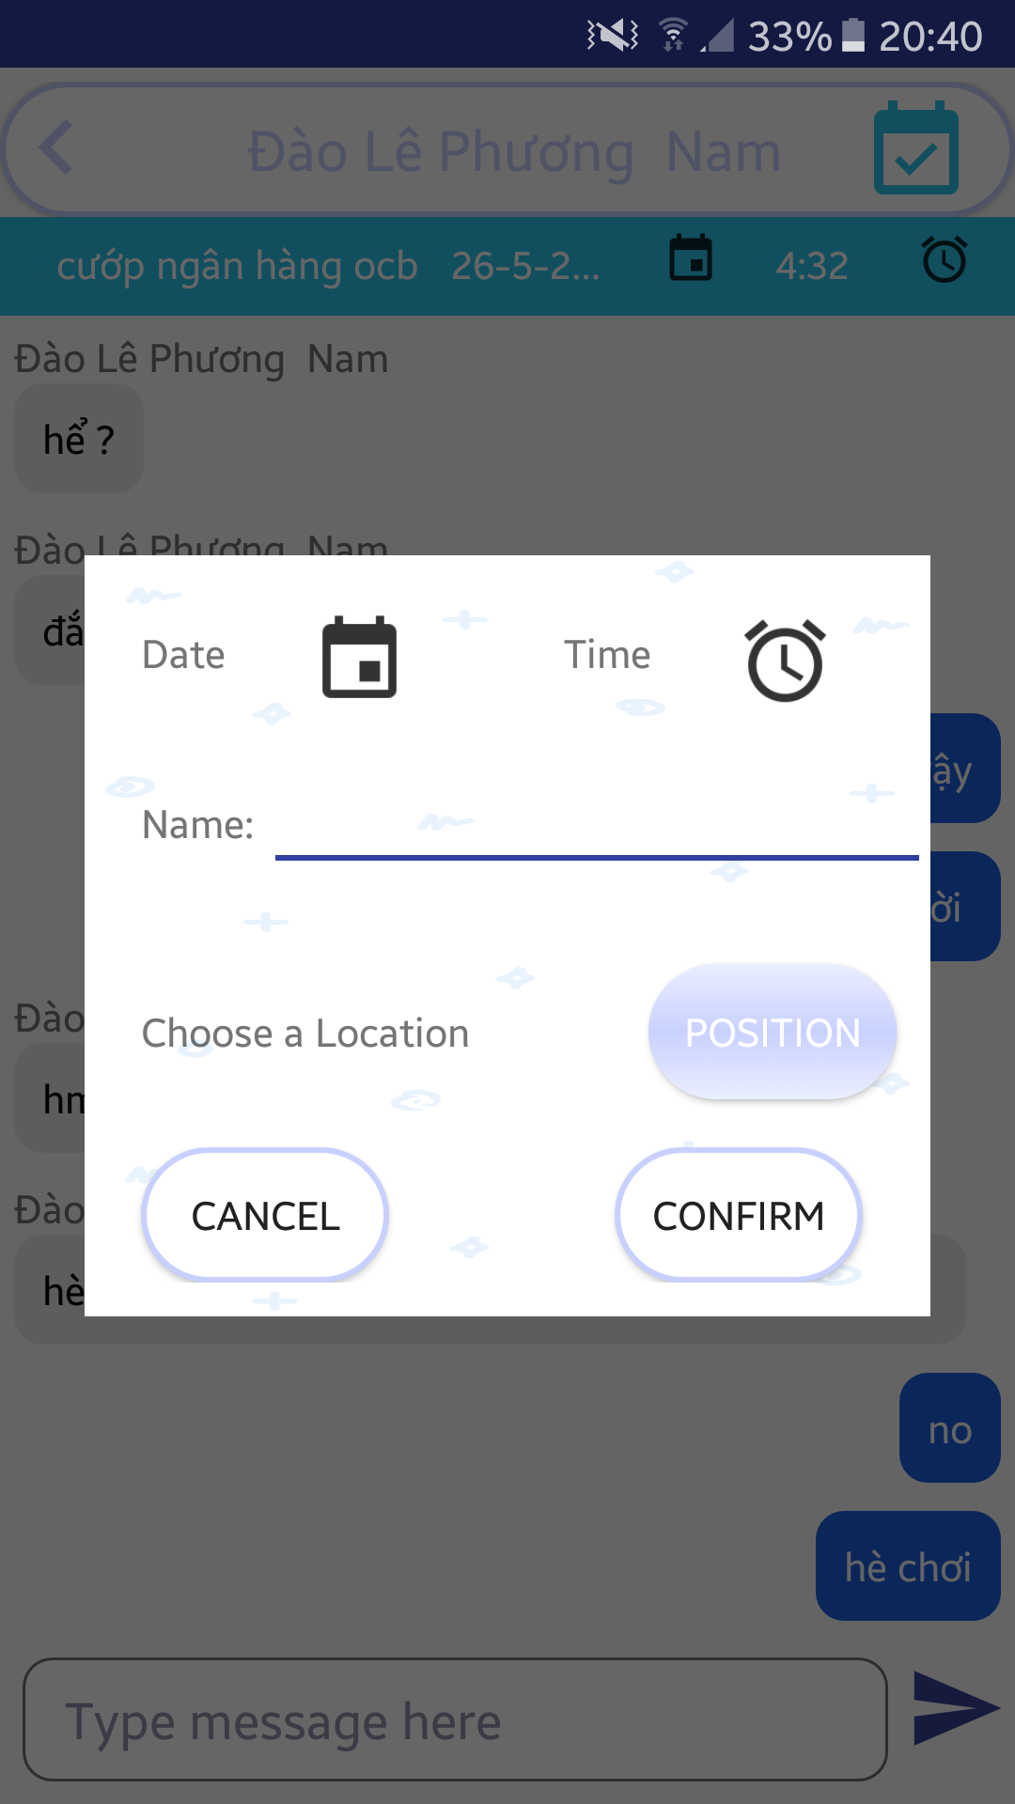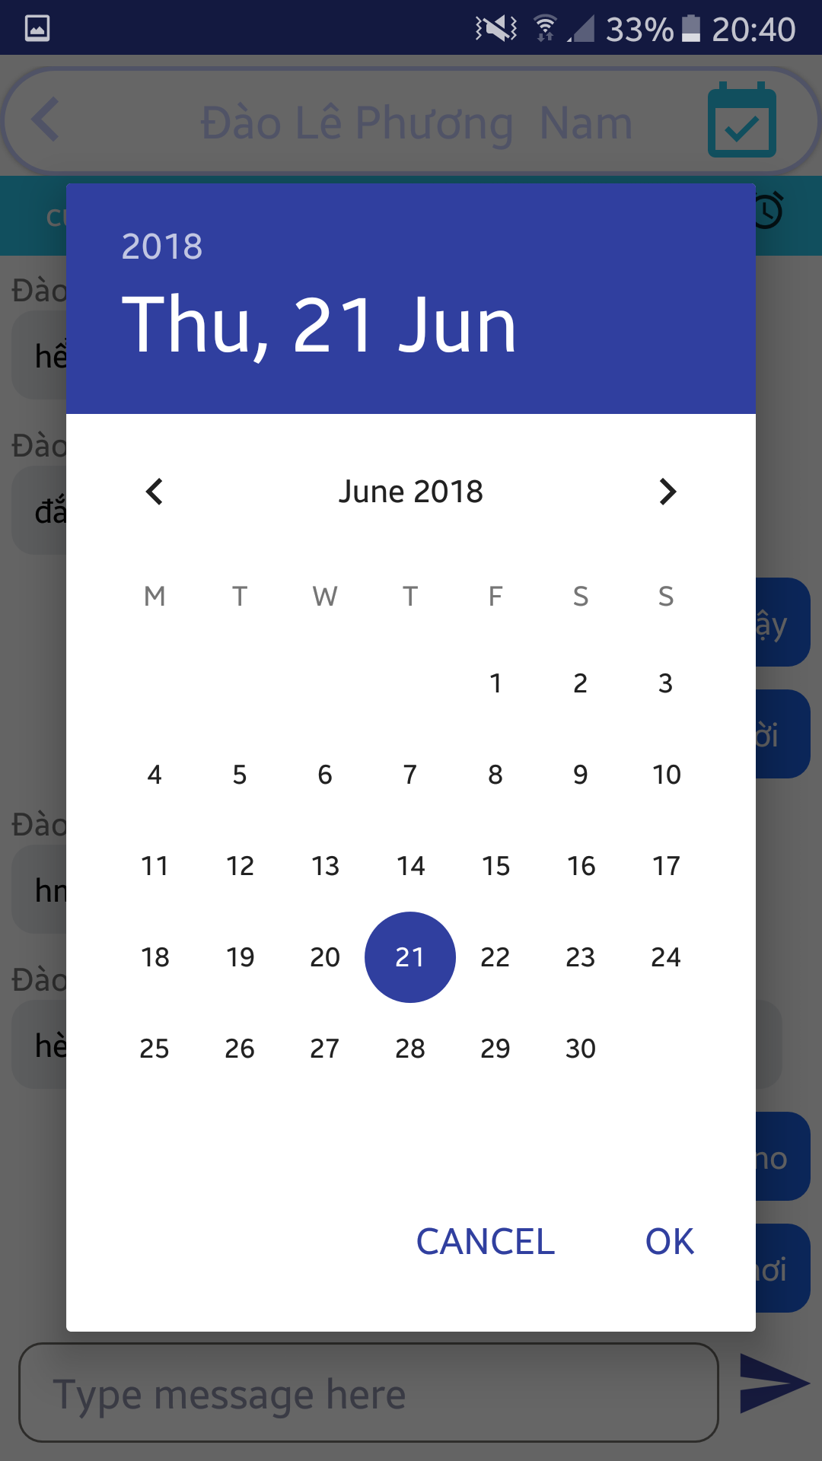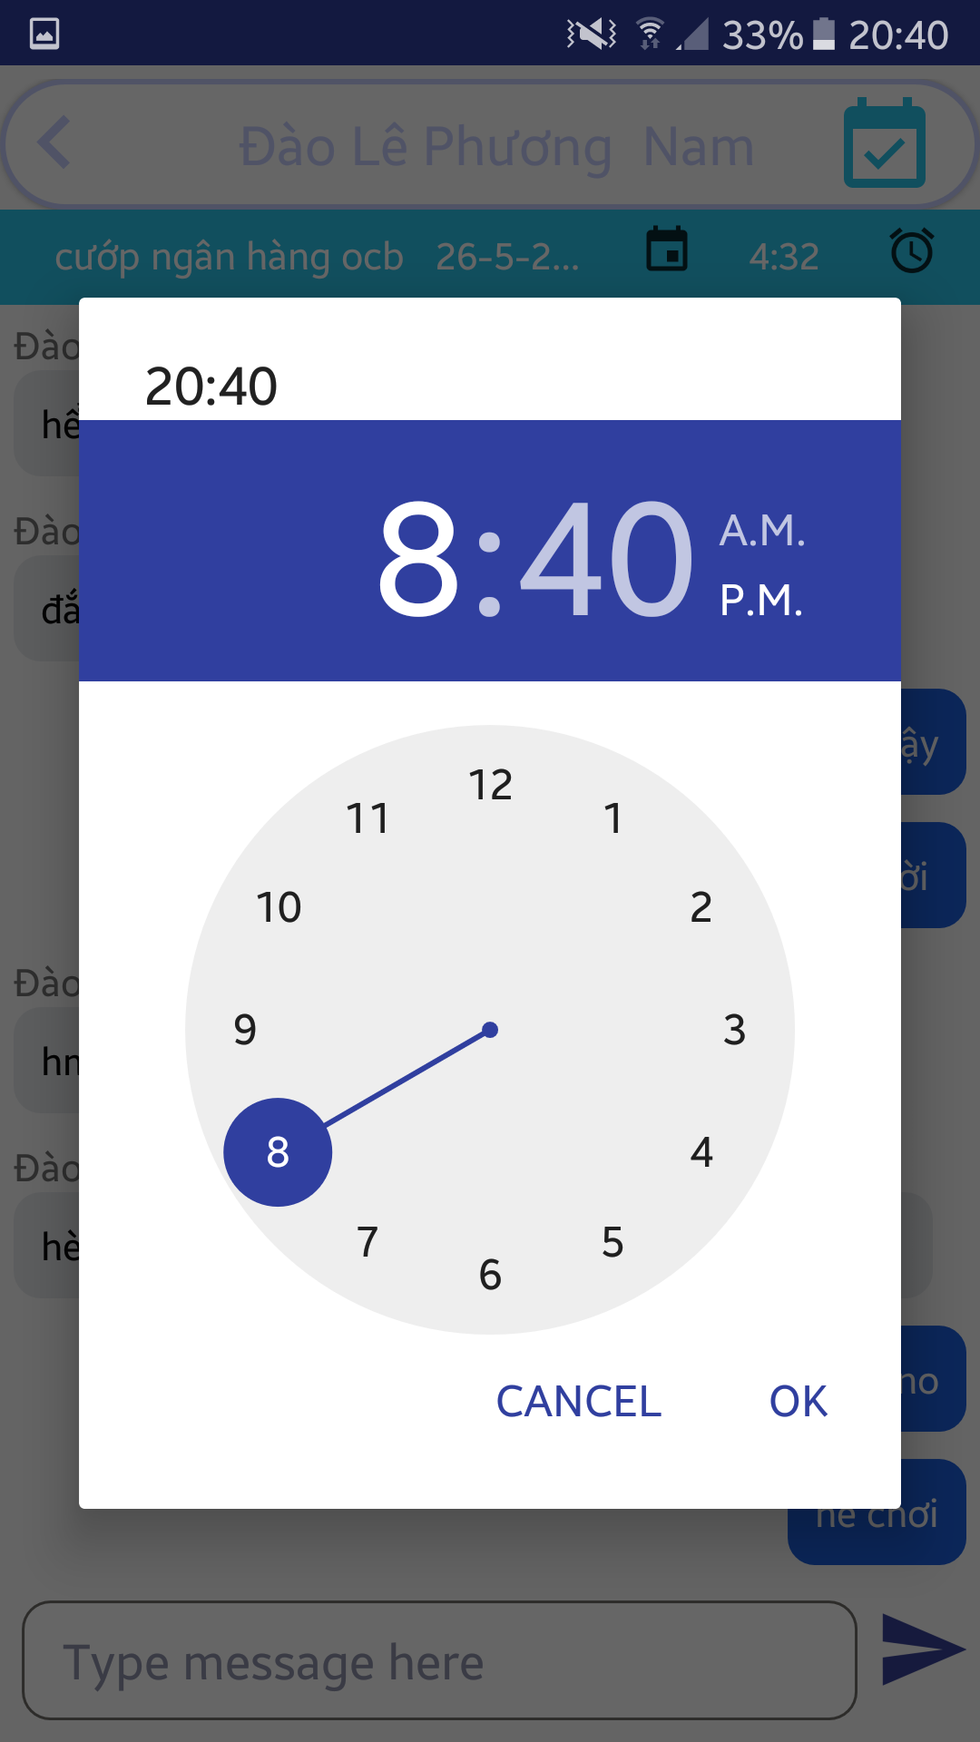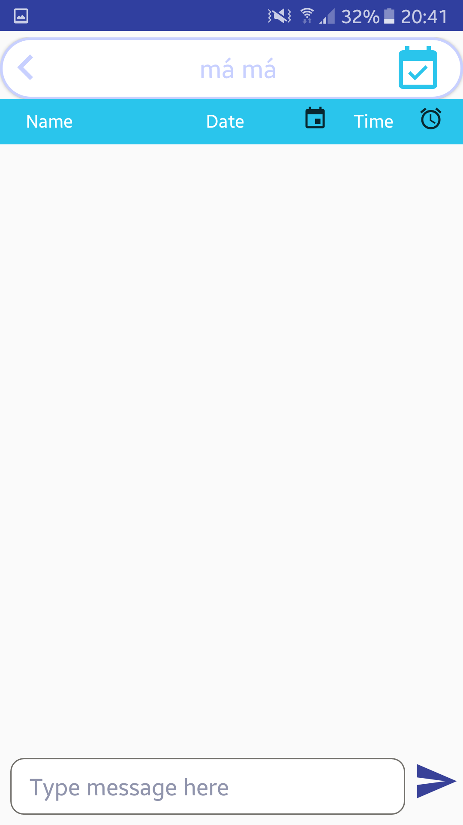

**Figure 2.6.1: Chat Figure 2.6.2: Set Meeting Figure 2.6.3: Calendar Figure 2.6.3: Time**

**Sreen 2.6.1**

|  |  |  |  |  |  |
| --- | --- | --- | --- | --- | --- |
| No | Component Name | Required | Format | Reference | Note |
| 1 | Back | None | Icon | Touch | Go back to screen 'Message' |
| 2 | Meeting | None | Icon | Touch | Show up Setting meeting panel |
| 3 | Type Message | String | Text Input | Keyboard | Enter content of message |

**Sreen 2.6.2**

|  |  |  |  |  |  |
| --- | --- | --- | --- | --- | --- |
| No | Component Name | Required | Format | Reference | Note |
| 1 | Clock | None | Icon | Touch | Show up view Clock |
| 2 | Calendar | None | Icon | Touch | Show up view Calendar |
| 3 | Name | String | Text Input | Keyboard | Enter topic of meeting |
| 4 | Position | None | Button | Touch | Show screen Location |
| 5 | Cancel Create | None | Button | Touch | Close setting meeting |
| 6 | Confirm Create | None | Button | Touch | Set meeting |

**Sreen 2.6.3, 2.6.4**

|  |  |  |  |  |  |
| --- | --- | --- | --- | --- | --- |
| No | Component Name | Required | Format | Reference | Note |
| 1 | Clock | Time | View | None | Show meeting's time |
| 2 | Date | DateTime | View | None | Show meeting's date |

# Other considerations

This UI provides fully the software application's feature request of group. Furthermore, it's so classical and familar to the users, including inexperienced ones.